CPE 324-01: Advanced Logic Design Laboratory

Lab03

Electrical and Timing Characteristics of Digital Hardware

Submitted by: Esther Shore

Date of Experiment(s): February 6, 2024 and February 8, 2024

Report Deadline: February 20, 2024

1. Introduction

This lab exposes us to utilizing various test equipment within the Advanced Logic Design Laboratory to gain practical experience observing and understanding some of the basic electrical considerations that are important to successful digital design. Empirical exploration of some of the lower-level electrical and timing characteristics that are important digital design is accomplished through a set of seven experiments, which involve the Terasic DE2-115 digital rapid prototyping platform, a logic probe, a digital multimeter, an oscilloscope, and amplified speaker, and a simple AM radio.

1. Experiment Description

2.1 Experiment #1: Basic Voltage Measurements from the DE2-115

In this experiment, we used the digital multimeter to measure the actual 5V and 3V3 supply signals that come from the DE2-115 and are brought out to the 40 pin breakout board. In order to accomplish this, it was necessary to understand how to use a digital multimeter to measure voltage with respect to ground.

2.2 Experiment #2: DE2-115/TTL Device Output Voltage Measurements

The goal of this experiment was to measure the output voltage of the switch signal before and after passing through an inverter, using both a digital multimeter and a logic probe, to observe changes in logic levels. A 74LS04 hex inverter IC was connected to the DE2-115 development board, with its input tied to SW0 and its output connected to LEDG0. To execute this experiment, we required further knowledge of reading the 74LS04 datasheet as seen in Figure 1 below as well as interpreting the logic truth table and circuits in addition to proficiency in using a digital multimeter and logic probe.

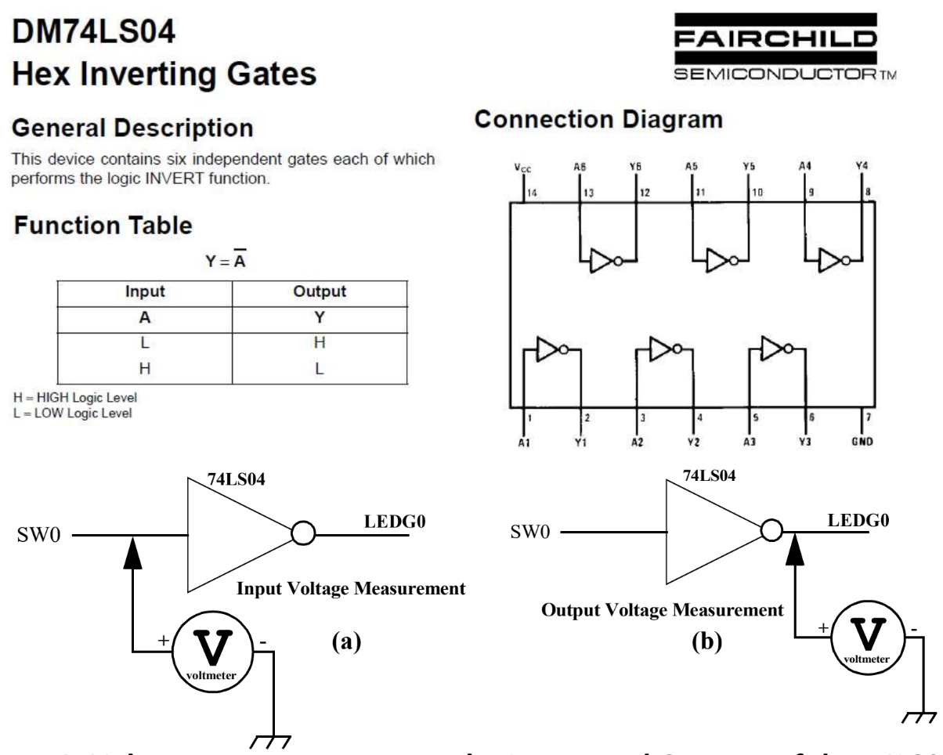

**Figure 1.** 74LS04 IC Datasheet and Voltage Measurement Diagrams

2.3 Experiment #3: TTL and CMOS Voltage Threshold Evaluation

Using a potentiometer setup, this experiment involved empirically determining the voltage threshold for logic high (V_IH) and logic low (V_IL) for both TTL and CMOS devices. We learned how to connect a potentiometer, which allowed us to vary the input voltage from 0 to 5 volts, monitoring the digital multimeter and logic probe and establishing acceptable voltage ranges for interpretation as logic high or low.

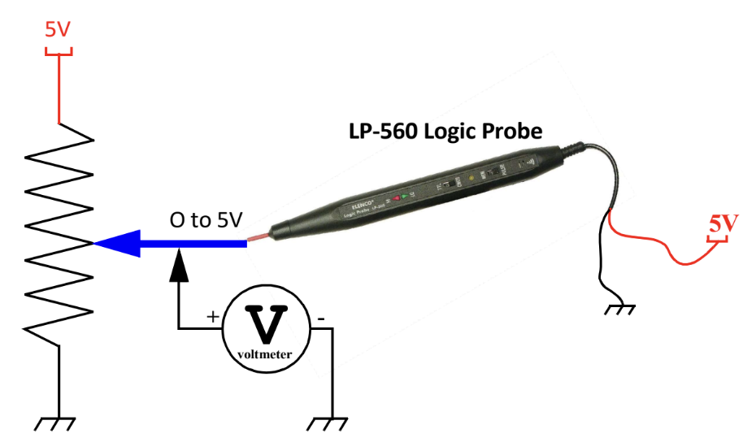

**Figure 2.** Potentiometer Experimental Setup

2.4 Experiment #4: Connecting Outputs Together Standard TTL

We observed what happened when standard TTL logic gates, such as the 74LS04, which are not internally designed to have their outputs connected to other similar gates, have their outputs connected. This setup is shown in Figure 3 below.

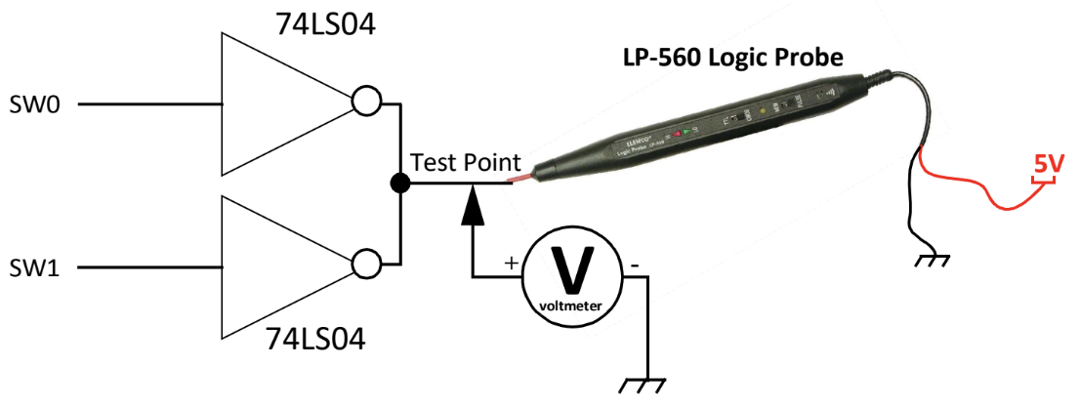

**Figure 3.** Connecting Multiple Outputs Together Standard TTL

2.5 Experiment #5: Connecting Outputs Together Standard Open Collector TTL

We repeated Experiment #4 but using 74LS05 IC hex inverters with open-collector outputs and a 1kW external pull-up resistor applied instead of the 74LS04 ICs. These gates are specifically designed so that connecting outputs together will perform an actual logic function (shown in Figure 4), called a wired logic function. We observed the behavior of connected outputs under this new configuration as displayed in Figure 5 below.

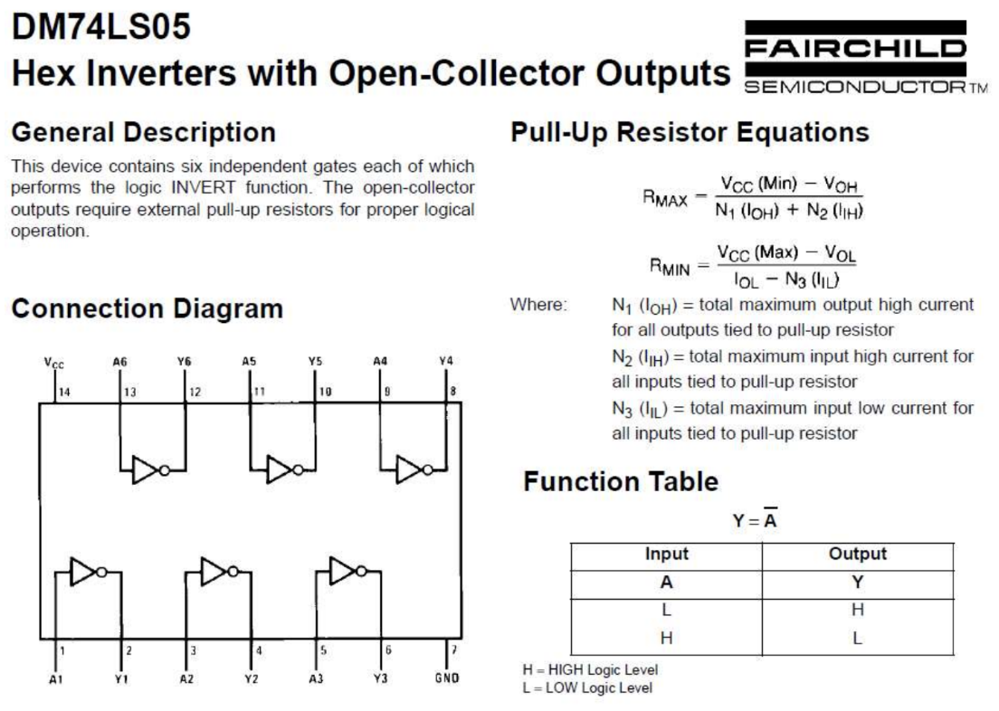

**Figure 4.** Partial Datasheet for 74LS05

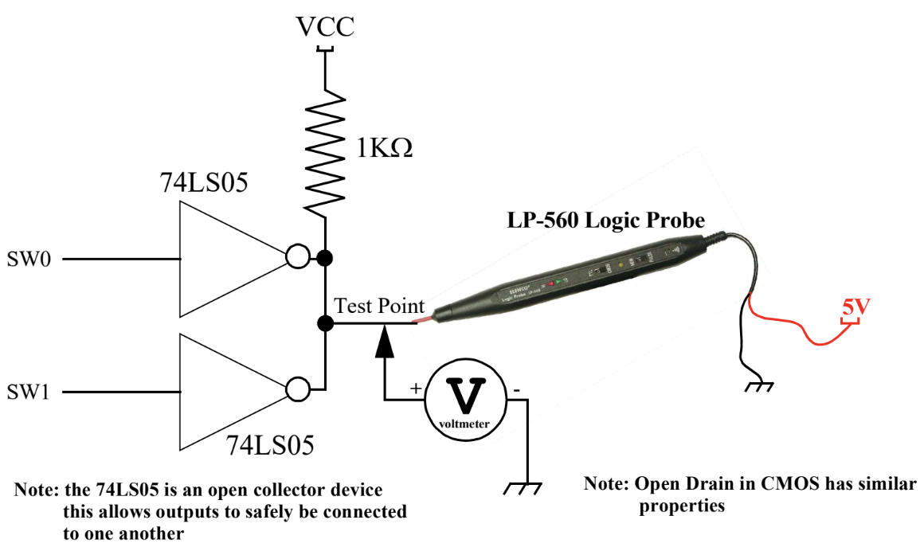

**Figure 5.** Connecting Multiple Outputs Together Open Collector TTL

2.6 Experiment #6: Tri-State Experiment

For different input switch states, we observed the behavior of connecting the outputs of two 74LS125 ICs together. These quad 3-state buffer circuits datasheet and logic is shown in Figure 6 below while the experimental setup is shown in Figure 7.

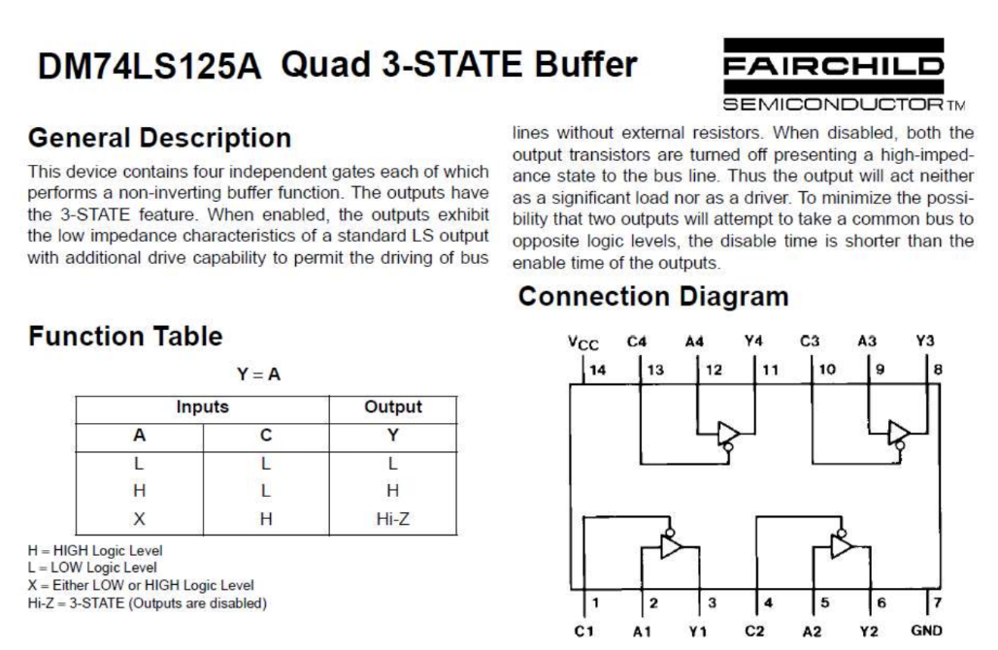

**Figure 6.** Partial Datasheet 74LS125

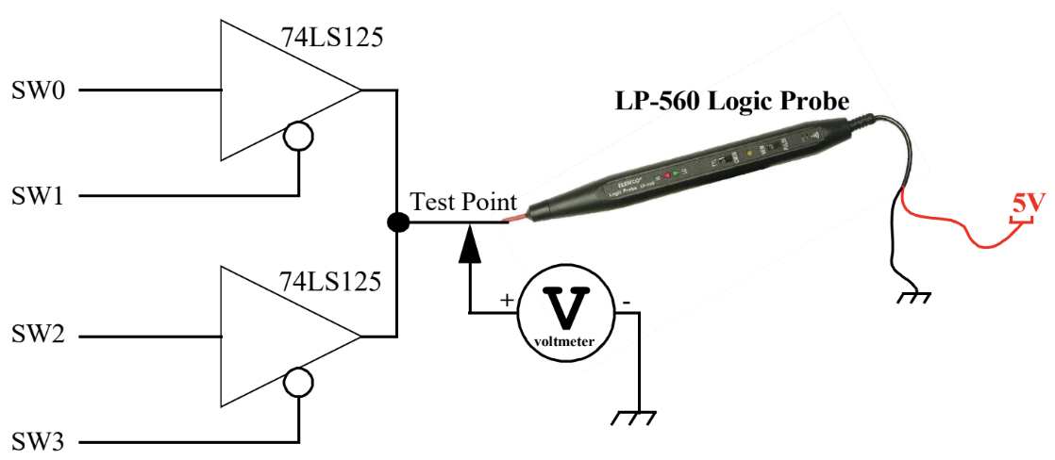

**Figure 7.** Connecting Multiple Tri-State Outputs Together

2.7 Experiment #7: Signal Integrity, Crosstalk, and Electromagnetic Radiation Issues

This experiment utilizes an oscilloscope, amplified speaker, and DE2-115 trainer to observe signal integrity, crosstalk, and electromagnetic radiation issues associated with high-speed clock signals in modern synchronous designs. We monitored the sound output from the speaker, analyzed waveform deviations from the ideal shape on the oscilloscope, measured frequency and peak-to-peak voltage, observed the output of the HEX6 LED on the DE2-115 board, and detected any electromagnetic radiations using a standard AM receiver at different clock rates. To provide valuable insights we had to understand how to use and read an oscilloscope as well as breadboard out system properly referring to Figure 8.

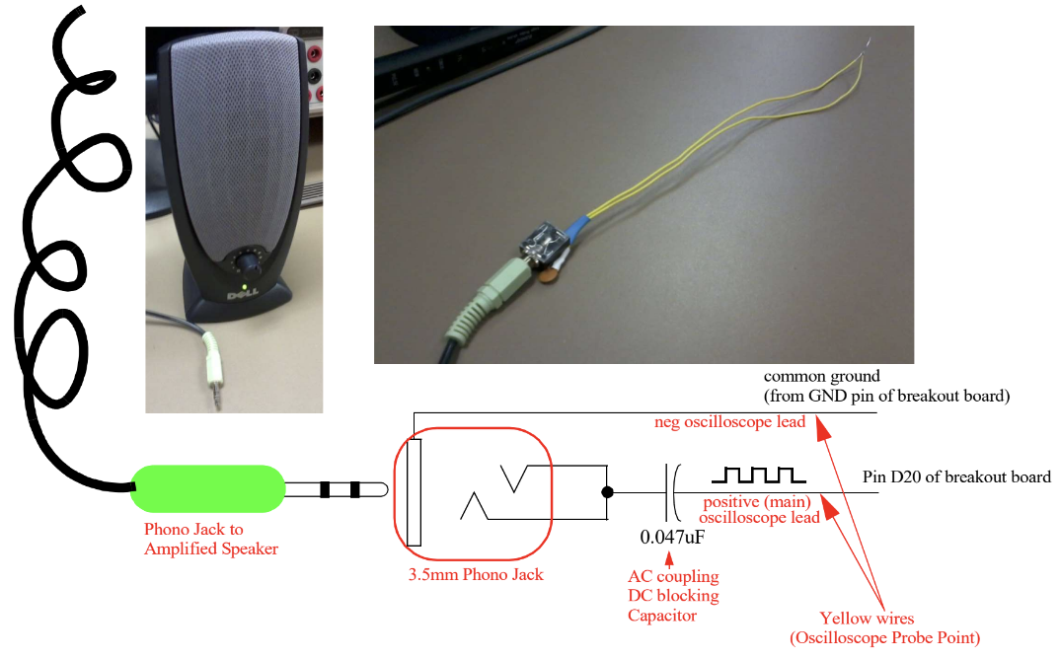

**Figure 8.** Clock Measurement Setup

In order to better understand our results of this experiment, we had to examine a few key definitions of terms related to the timing and electrical characteristics of digital logic:

* Crosstalk - undesired electromagnetic interference between signals on adjacent lines or components, resulting in possible signal degradation or incorrect operation
* Clock skew - the difference in arrival times of the clock signal at different points in the circuit
* Rise time - the time taken for a signal to transition from a low to a high state
* Fall time - the time taken for a signal to transition from a high to a low state
* Propagation delay - the time taken for a signal to travel through a logic gate or a circuit path from input to output
* Setup time - the minimum time that a data input must be stable before the active edge of the clock signal for a proper capture by a flip-flop or latch
* Hold time - the minimum time that a data input must remain stable after the active edge of the clock signal to ensure proper data capture

1. Demonstration

3.1 Experiment #1: Basic Voltage Measurements from the DE2-115

We recorded the actual 5V and 3V3 DC supply signals from the DE2-115.

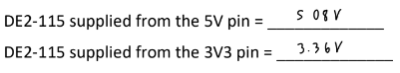

**Figure 9.** Experiment 1 Data

3.2 Experiment #2: DE2-115/TTL Device Output Voltage Measurements

The voltage and logic level going into the inverter was recorded in Figure 10. The voltage and LED logic status coming out of the inverter was also recorded in Figure 10.

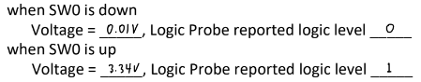

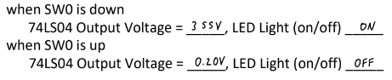

**Figure 10.** Experiment 2 Data

3.3 Experiment #3: TTL and CMOS Voltage Threshold Evaluation

For both TTL and CMOS modes of the logic probe, the threshold voltage levels for logic high and logic low were experimentally determined by varying the voltage with the potentiometer and observing the logic probe result.

**Table 1.** Experiment 3 Data

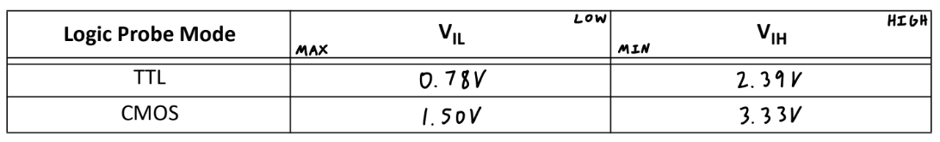

3.4 Experiment #4: Connecting Outputs Together Standard TTL

The measured output voltage and TTL logic level was recorded for the two inverter ICs with their outputs connected for all switch input combinations.

**Table 2.** Experiment 4 Data

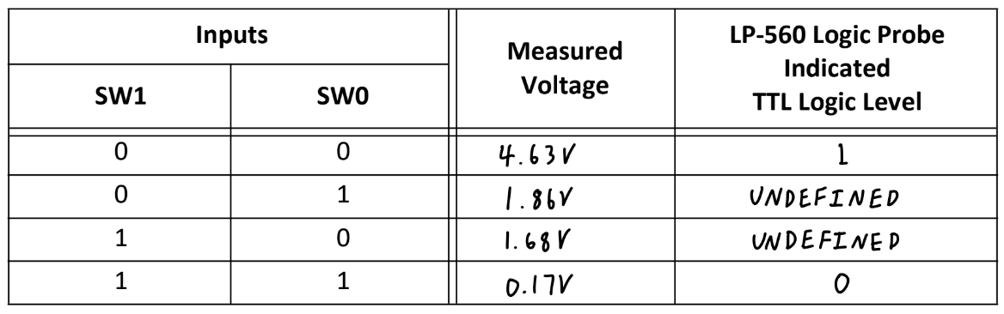

3.5 Experiment #5: Connecting Outputs Together Standard Open Collector TTL

We noted the output voltage and TTL logic level for a circuit with the outputs of two inverter ICs with open-collector outputs connected and a 1kW pull-up resistor applied.

**Table 3.** Experiment 5 Data

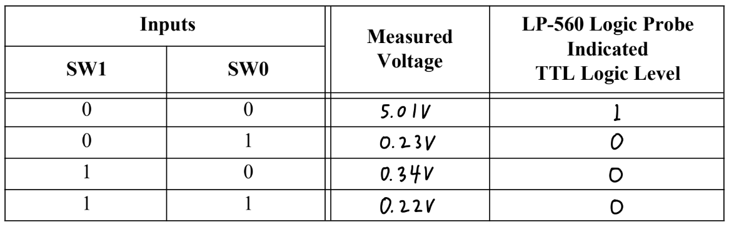

3.6 Experiment #6: Tri-State Experiment

We recorded the measured output voltage and TTL logic level for the circuit with

two tri-state outputs connected together.

**Table 4.** Experiment 6 Data

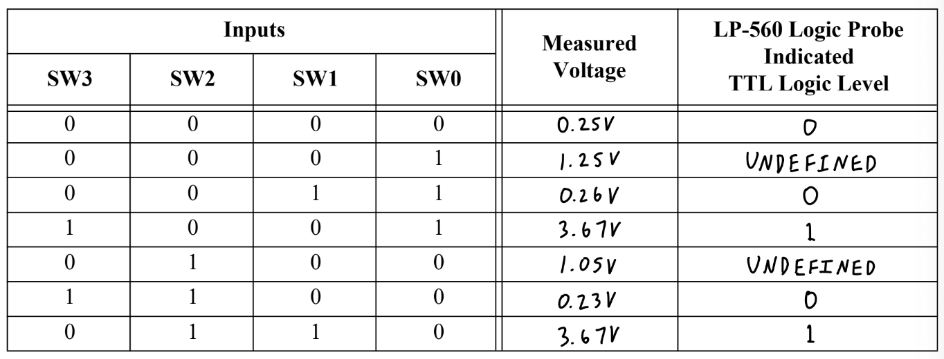

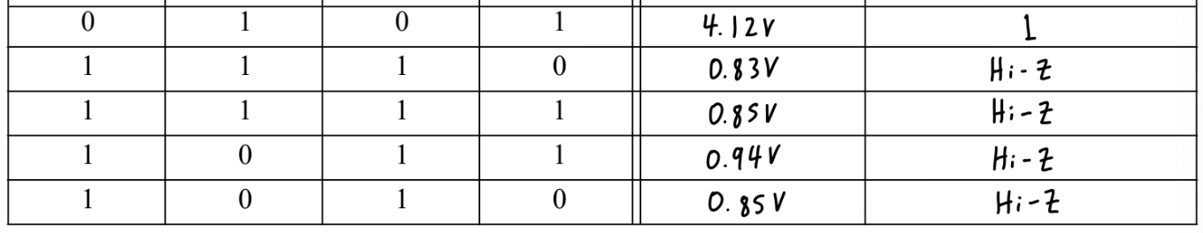

3.7 Experiment #7: Signal Integrity, Crosstalk, and Electromagnetic Radiation Issues

We connected the LED and speaker according to the lab manual instructions as shown in Figure 11, each driven by the clock output of the DE2-115. We observed the waveform for each clock frequency on the oscilloscope as exhibited in Figures 12 through 16.

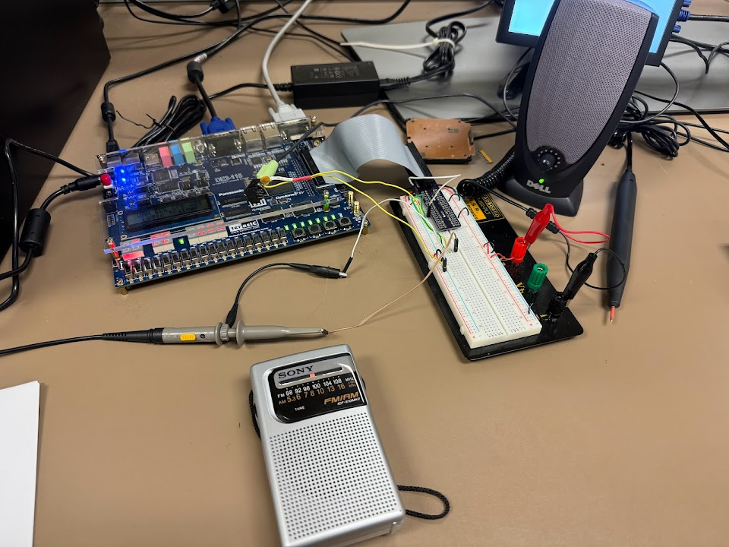

**Figure 11.** Experiment 7 Setup

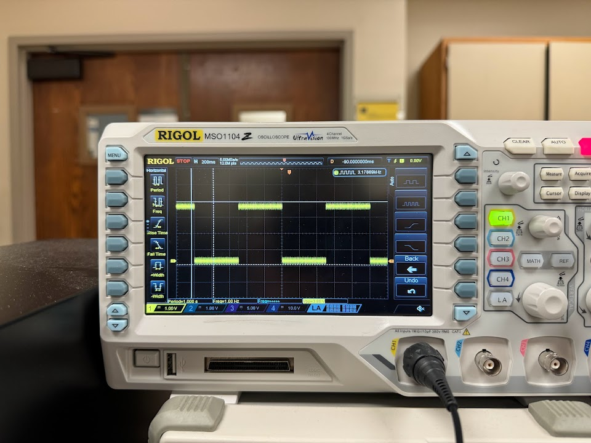

**Figure 12.** Very Slow Clock Waveform

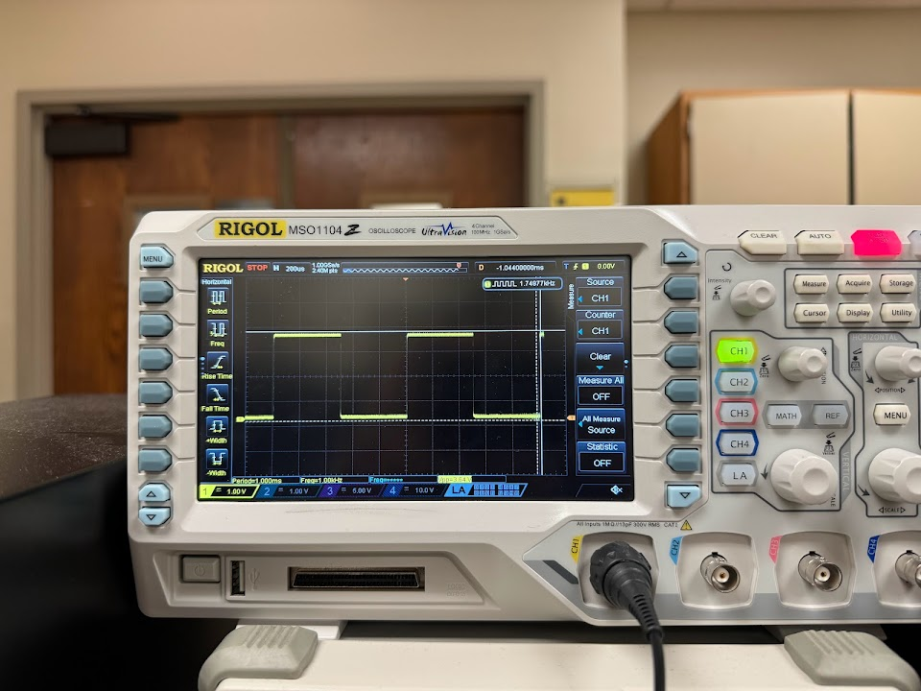

**Figure 13.** Slow Clock Waveform

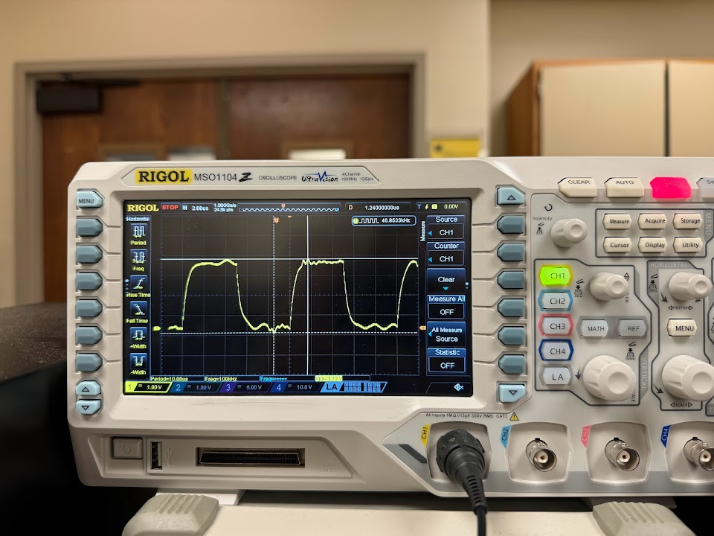

**Figure 14.** Medium Clock Waveform

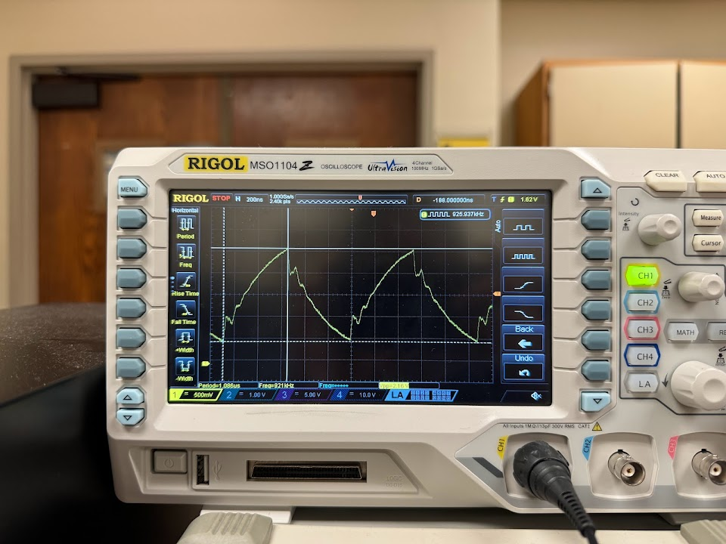

**Figure 15.** Fast Clock Waveform

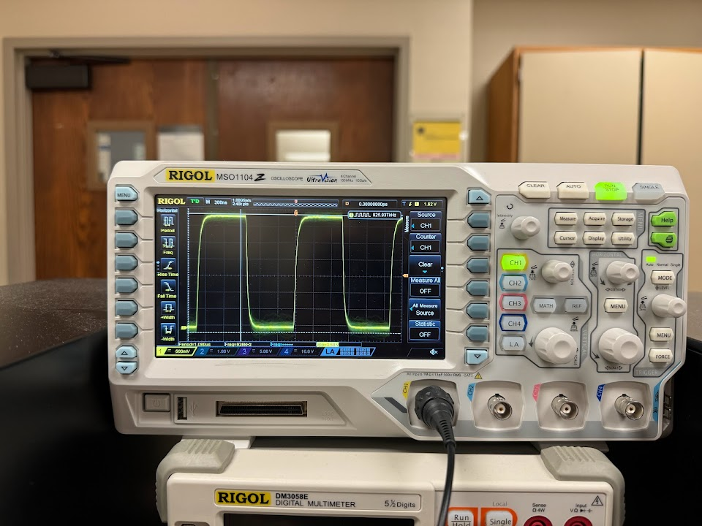

**Figure 16.** Fast Clock Waveform When Phono Plug Removed

1. Experimental Results

4.1 Experiment #1: Basic Voltage Measurements from the DE2-115

The observed voltage supplied from the 5V pin of 5.08V was very close to the expected value of 5V. The same went for the voltage supplied from the 3V3 pin, measuring in at 3.36V.

4.2 Experiment #2: DE2-115/TTL Device Output Voltage Measurements

The voltage corresponding to a logic level of high was around 3.3V while a logic level of low was approximately 0V. This makes sense as this is the voltage supplied by the DE2-115 and was reaffirmed by the logic probe readings, showing a clear distinction between logic high and low states. The output voltage from the inverter reflected the inverted logic level through both the multimeter and voltage probe readings.

TTL uses positive logic, meaning a logic high corresponds to a higher voltage level and a logic low corresponds to a lower voltage level.

4.3 Experiment #3: TTL and CMOS Voltage Threshold Evaluation

The VLTTL output voltages generally fell within the acceptable region for a TTL to interpret as a logic high or a logic low. Values including and below 0.78V were registered as logic low while values including and above 2.39 were registered as logic high. This is comparable to the reported values on the datasheet for the 74LS04 IC of 2V for V_IH and 0.8V for V_IL.

The CMOS logic exhibited higher output voltage thresholds for determining voltage high and low values, implying less sensitivity in detecting a logic high and greater sensitivity in detecting a logic low.

4.4 Experiment #4: Connecting Outputs Together Standard TTL

There were some voltage levels observed that were in the so-called forbidden region where the voltage present at the input of the logic probe has a value that is in between the range interpreted as a valid logic high or a logic low for TTL logic. This included both of the cases where only one switch was set active, resulting in an undefined logic level by the logic probe. These cases occur because the resulting outputs from each of the two ICs are contradictory to each other, one is outputting a 1 while the other is outputting a zero. The resulting intermediary voltage levels are where the logic probe detects neither a high or low logic level because the ICs are not intended to have their outputs connected.

4.5 Experiment #5: Connecting Outputs Together Standard Open Collector TTL

In contrast to the previous experiment, the 75LS05 ICs are able to handle having their outputs connected and handle all the intermediary states by setting the output to a low voltage level of logic 0. Thus, there are no voltage levels in the forbidden TTL region and each input combination corresponds to a distinct logic level without ambiguity.

The logic function expressed by the truth table is a NOR gate, where the output is high only when both inputs are low. If TTL logic were negative, the truth table would represent an OR gate, where the output is low only when both inputs are low.

4.6 Experiment #6: Tri-State Experiment

The tri-state logic differs from open-collector or open-drain configurations as it allows a digital signal to assume one of three possible states: high (1), low (0), or high-impedance (Z). In the latter two configurations, external pull-up resistors determine the output value when the transistor is turned off or logic high. When a signal is hi-Z, or tri-stated, it is essentially inactive and allows other devices to use the same bus without interference.

Tri-state devices can be used in many CPU memory architectures for address and data buses, where multiple memory modules are connected to a shared bus, enabling efficient sharing of the bus among multiple devices without causing conflicts.

4.7 Experiment #7: Signal Integrity, Crosstalk, and Electromagnetic Radiation Issues

For each of the four clock speeds, we noted the speaker, waveform, and LED behavior. The speaker sounds were driven by the clock, perhaps inducing electromagnetic current from the rapid voltage changes. The waveforms deviated from the ideal square wave shape due to various factors such as capacitance and inductance within the circuit causing signal reflections as well as impedance mismatches. As the clock frequency increased, the waveform appeared more distorted like a sawtooth shape. Disconnecting the speaker from the clock driver resulted in a sharper, more ideal waveform. This could be due to the reduction in load on the output, thereby reducing any interfering effects of the attached external peripheral to the system. The HEX6 LED blink frequency corresponded to the input clock signal, but at higher frequencies appeared static due the rapidness of the state changes, which was expected behavior.

Electromagnetic transmission observations when an AM radio was held closer to the clock are recorded in addition to other observations for each case in Figures 17 through 20 below.

The generally accepted audio frequencies span from about 20 Hz to 20 kHz, while radio frequencies can range from approximately 3 kHz to multiple gigahertz. This knowledge helps us explain why the speaker sound diminished at higher frequencies. It also explains why the AM radio sound continued to be distorted by the clock at the faster clock speeds, possibly due to crosstalk or other effects of signal interference.

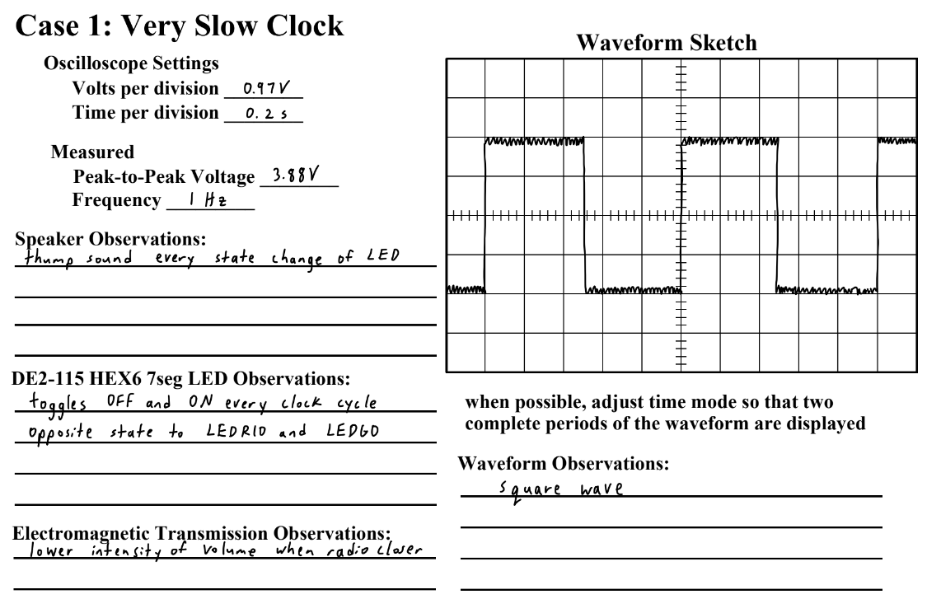

**Figure 17.** Very Slow Clock Results and Observations

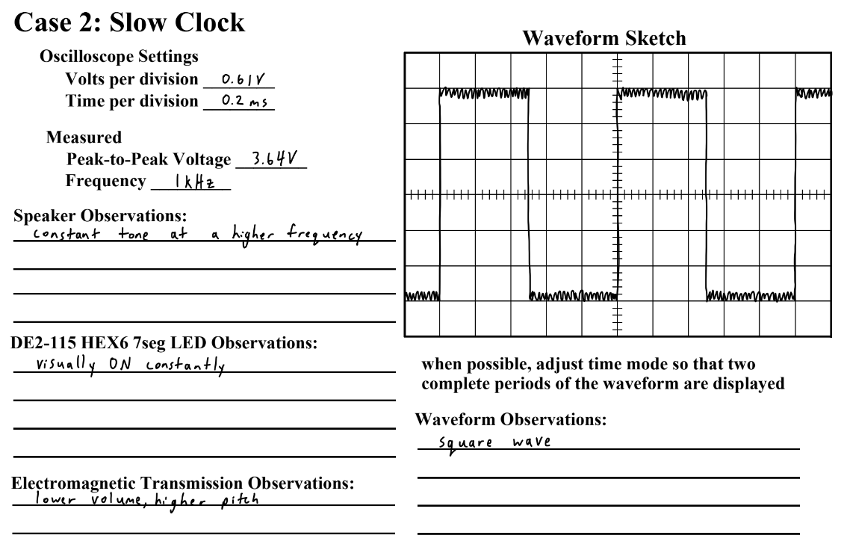

**Figure 18.** Slow Clock Results and Observations

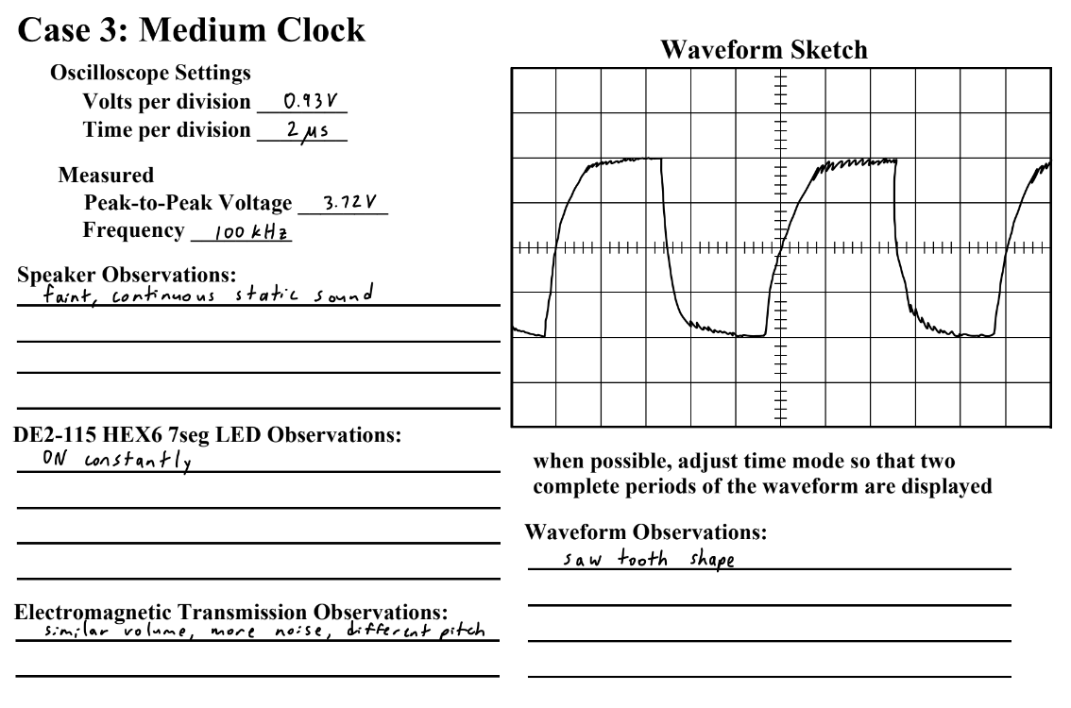

**Figure 19.** Medium Clock Results and Observations

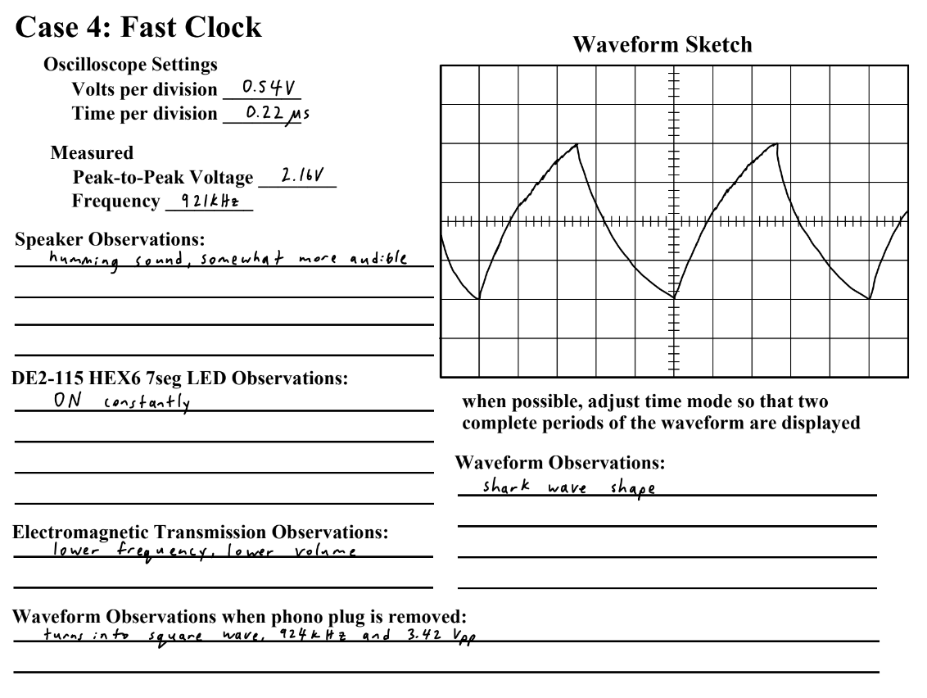

**Figure 20.** Fast Clock Results and Observations

1. Conclusion

Overall, this laboratory provided valuable hands-on experience in understanding the fundamental electrical and timing characteristics crucial for successful digital design. Through a series of experiments, we explored concepts such as voltage measurements, logic level interpretation, threshold evaluations for TTL and CMOS devices, and the behavior of various logic gates and configurations. Additionally, we investigated signal integrity issues, crosstalk, and electromagnetic radiation effects associated with high-speed clock signals, gaining insights into the practical challenges encountered in modern synchronous designs.